ANOVA?
ANOVA, or Analysis of Variance, is a statistical method used to determine if there are significant differences between the means of three or more independent groups.
While a t-test compares the means of exactly two groups, ANOVA allows for the simultaneous comparison of multiple groups, which helps prevent the increased risk of a "false positive" (Type I error) that occurs when running many individual t-tests.
Core Concepts
The "Analysis of Variance" name comes from the way the test works: it compares the variance between groups (how much the group means differ from each other) to the variance within groups (how much the individual data points within each group spread out).
- If the variation between the groups is significantly larger than the variation within the groups, it suggests the groups are truly different.
- The result is reported as an F-statistic. A higher F-value usually indicates a more significant difference.

Common Types of ANOVA
- One-Way ANOVA: Used when you have one independent variable (factor) with three or more levels.
  - Example: Comparing the test scores of students using three different study methods (Method A, Method B, and Method C).
- Two-Way ANOVA: Used when you have two independent variables and want to see how they both affect the outcome, as well as if they "interact" with each other.
  - Example: Comparing test scores based on both the study method and the time of day (morning vs. evening).
- Repeated Measures ANOVA: Used when the same subjects are measured multiple times under different conditions.
  - Example: Testing the same group of people’s blood pressure before, during, and after a specific treatment.

Key Assumptions
For the results of an ANOVA to be valid, the data should generally meet these criteria:
- Normality: The distribution of the residuals (errors) should be approximately normal.
- Homogeneity of Variance: The variance (spread) among the groups should be roughly equal.
- Independence: The observations in each group must be independent of each other.

What is a Statistical Test?
A statistical test is a method used to make a decision about a population parameter using sample data. It helps us determine whether to accept or reject the null hypothesis based on evidence.
Steps in Testing Hypothesis
1. State the Hypotheses
Null hypothesis Ho (no effect)
Alternative hypothesis H₁ (effect exists)
2. Choose Level of Significance (a)
Usually 0.05 or 0.01
3. Select the Test Statistic
Z-test, t-test, Chi-square, etc.
4. Calculate the Test Statistic
Using sample data and formula
5. Determine Critical Value / Region
From statistical tables
6. Make Decision
Reject Ho if test statistic falls in critical region Otherwise, do not reject Ho

What is level of significance? Explain its importance.
The level of significance is the probability of rejecting a true null hypothesis. It is denoted by a, commonly taken as 0.05 or 0.01.
Importance:
1. It helps in deciding whether to reject or accept the null hypothesis.
2. It controls the risk of committing a Type I error.
3. It provides a standard for comparing the test statistic.
4. It ensures reliability and accuracy in statistical decision-making.

What is Hypothesis?
A hypothesis is a specific, testable claim or prediction about a population.

Difference Between Null and Alternative Hypothesis
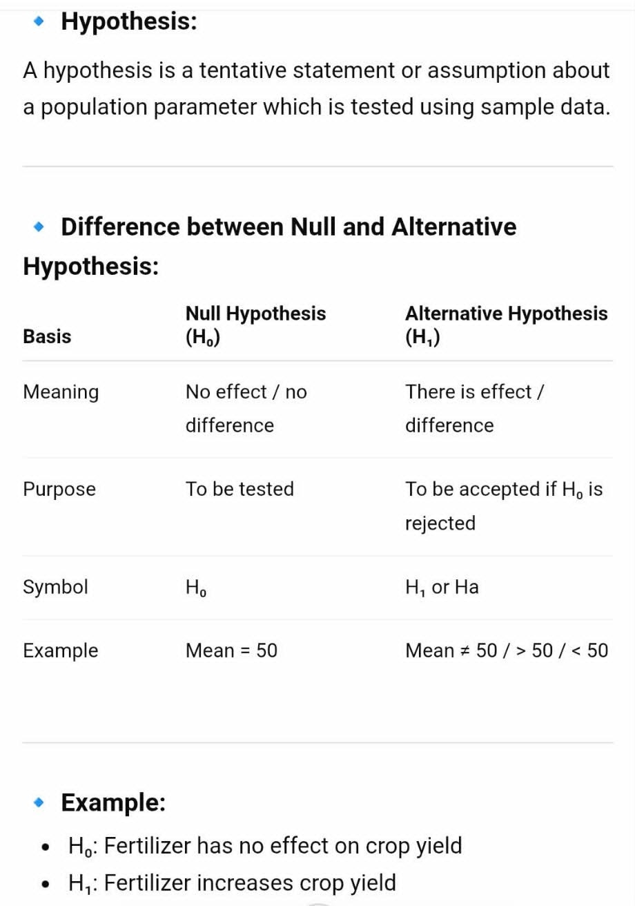
Type I Error | Type II Error
Rejecting a true null hypothesis | Accepting (failing to reject) a false null hypothesis
Denoted by α (alpha) | Denoted by β (beta)
False positive | False negative
Concluding there is an effect when there is none | Concluding there is no effect when there actually is
Example: Saying a medicine works when it actually does not | Example: Saying a medicine does not work when it actually does

Difference between Type I and Type II error

Hypothesis Testing
Hypothesis testing is a statistical method used to decide whether a statement or assumption about a population is true or false using sample data.

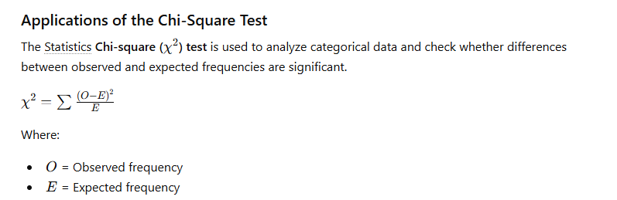

Main Applications of Chi-Square Test

1. Test of Goodness of Fit
Used to determine whether observed data follows a particular theoretical distribution.

Example:
Checking whether a dice is fair or not.
- Expected frequency for each face should be equal.
- If observed frequencies differ greatly, the dice may not be fair.

2. Test of Independence (Association)
Used to check whether two categorical variables are related or independent.

Example:
To determine whether smoking habits are related to lung disease.
Smoking | Disease | No Disease
Smoker | 40 | 20
Non-smoker | 10 | 30
The chi-square test tells whether smoking and disease are associated.

3. Test of Homogeneity
Used to compare whether different populations have the same proportion or characteristics.

Example:
Comparing voter preferences in different cities.
- City A, B, and C may have different political preferences.
- Chi-square checks whether the distributions are similar.

4. Genetics and Biology
Widely used in genetics to test inheritance ratios.

Example:
Testing Mendel’s genetic ratio such as 3:1 ratio in pea plants.

5. Market Research
Used in business and surveys to analyze customer preferences.

Example:
Checking whether customer preference for a product depends on gender or age group.

6. Education
Used to compare students’ performance categories.

Example:
Finding whether pass/fail results depend on teaching methods.

Define t-test and write the conditions for its application. Just write the application of cases

Definition of t-test
A t-test is a statistical test used to compare means when the sample size is small and population variance is unknown.

Conditions / Applications of t-test
- Sample size is small (usually n<30n < 30n<30)
- Population variance is unknown
- Data are approximately normally distributed
- Samples are randomly selected
- Observations are independent

Cases of t-test
- One-sample t-test
- Two-sample t-test
- Paired t-test

Significance of t-Test in Agriculture

1. Comparing Crop Varieties
Used to compare yields of two crop varieties.

Example:
Comparing maize yield between:
- Improved seed variety
- Local seed variety
If the calculated t-value is significant, the improved variety performs better.

2. Testing Fertilizer Effects
Helps determine whether different fertilizers produce significantly different crop yields.

Example:
Comparing production using:
- Organic fertilizer
- Chemical fertilizer

3. Evaluating Irrigation Methods
Used to compare two irrigation techniques.

Example:
- Drip irrigation
- Flood irrigation
The t-test shows whether the yield difference is statistically significant.

4. Pest and Disease Control Studies
Used to evaluate effectiveness of pesticides or treatments.

Example:
Comparing crop damage:
- Before pesticide application
- After pesticide application

5. Soil and Environmental Studies
Helps compare soil properties or environmental effects.

Example:
Comparing soil pH or moisture content from two fields.

What is Probability Distribution? Why is standardization of normal variate (normal distribution) done?

Probability Distribution
A probability distribution is a mathematical function that shows how probabilities are distributed among the possible values of a random variable.
In simple words:
It tells the chance of occurrence of different outcomes.

Example:
When a dice is thrown,
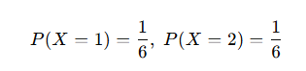
and so on.

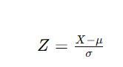
Why Standardization of Normal Variate is Done?
Standardization converts a normal variable XXX into a standard normal variable ZZZ.

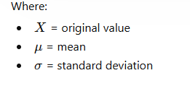

Purpose of Standardization
- To simplify calculations.
- To use standard normal distribution tables.
- To compare values from different datasets.
- Converts all normal distributions into one common form:
  - Mean =0=0=0
  - Standard deviation =1=1=1

Define the Normal Distribution. Write its Properties.
The normal distribution is a continuous probability distribution that is symmetric and bell-shaped around the mean.
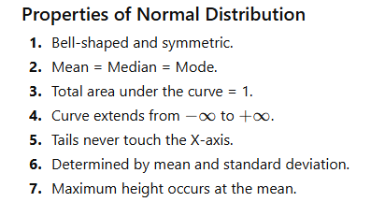

What are the Parameters and Properties of Normal Distribution?

Parameters of Normal Distribution
There are two parameters:

1. Mean (μ)
- Determines the center/location of the curve.

2. Standard Deviation (σ)
- Determines spread or width of the curve.

Properties of Normal Distribution
- Symmetrical distribution.
- Bell-shaped curve.
- Mean = Median = Mode.
- Total probability equals 1

Standard Normal Curve Diagram
The following diagram illustrates the standard normal distribution curve (z-curve) with its characteristic bell shape and area distributions based on standard deviation (z-scores)
The properties are:
- The total area under the standard normal curve represents total probability and is equal to 1
- Symmetry: The curve is symmetric around the mean (z=0). Therefore, 50% of the area lies to the left of z=0, and 50% lies to the right.
- Total Area: The total area under the curve is 1.
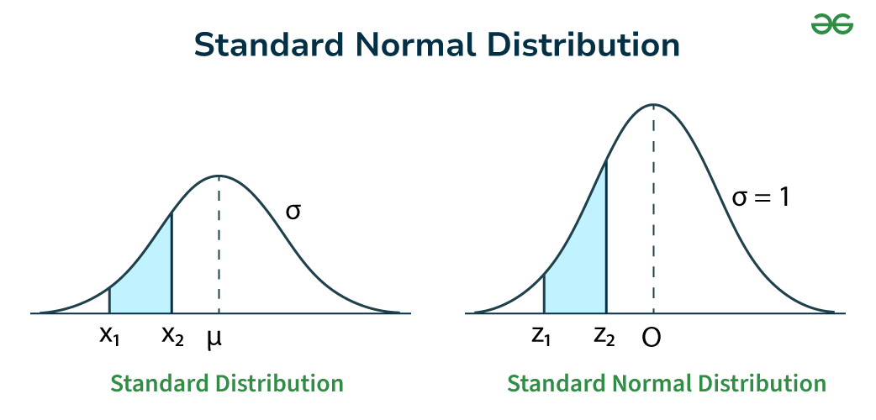

CRD (Completely Randomized Design)
The Completely Randomized Design (CRD) is the simplest experimental design in which treatments are assigned to experimental units completely at random.
It is commonly used in laboratory experiments, greenhouse studies, and agricultural research where experimental units are homogeneous.

Main Features of CRD
- Treatments are allocated randomly.
- Every experimental unit has an equal chance of receiving any treatment.
- Suitable when experimental materials are uniform.
- Number of replications may be equal or unequal.

RCBD (Randomized Complete Block Design)
The Randomized Complete Block Design (RCBD) is an experimental design in which experimental units are divided into homogeneous groups called blocks, and each block contains all treatments exactly once. It is widely used in agricultural research to reduce experimental error caused by variation in land or environment.

Main Features of RCBD
- Experimental units are divided into blocks.
- Each block contains all treatments.
- Treatments are assigned randomly within each block.
- Suitable when variation exists in one direction.

LSD (Least Significant Difference)
Statistics The Least Significant Difference (LSD) test is a statistical method used to compare the means of two treatments after performing Analysis of Variance ANOVA.
It helps determine whether the difference between treatment means is statistically significant.

Purpose of LSD
- To compare individual treatment means.
- To identify which treatments differ significantly.
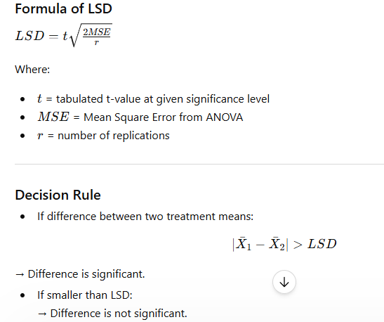

(2X2) factorial design
A 2² (2X2) factorial design is an experimental design involving:
- 2 factors
- Each factor has 2 levels
So, total treatment combinations:
2² = 4

Example

Factors:
- Factor A → Fertilizer (A₁, A₂)
- Factor B → Irrigation (B₁, B₂)
Treatment Combinations
Treatment | Combination
1 | A₁B₁
2 | A₁B₂
3 | A₂B₁
4 | A₂B₂

2×3 (2³) factorial design
2×3 factorial design is an experimental design involving:
- One factor with 2 levels
- Another factor with 3 levels
Total treatment combinations:
2×3 = 6

Example
- Factor A (Fertilizer): A₁, A₂
- Factor B (Irrigation): B₁, B₂, B₃

Treatment Combinations
- A₁B₁
- A₁B₂
- A₁B₃
- A₂B₁
- A₂B₂
- A₂B₃

